**Experiment Name:**

Write a program that lets the user type some text, consisting of words separated by blanks, ending with a carriage return and displays the text in the same word order as entered, but with the letters in each word reversed.

**Theory:**

The objective of this program is to reverse each word of a text by the same order as they were taken as input. That reversed string or text need to be printed in the output. For this program in assembly, While loop, CMP, Stack, array was used as well as the required instructions and some registers to execute the solution.

**Code:**

.MODEL SMALL

.STACK 100H

.CODE

.DATA

PROMPT DB 'Type a String: $'

ARR DB 50 DUB (?)

MAIN PROC

MOV AX,@DATA

MOV DS,AX

XOR BX,BX

XOR CX,CX

MOV AH,9

LEA DX,PROMPT

INT 21H

C:

MOV AH,1

INT 21H

CMP AL,0DH

JE END_WHILE

PUSH AX

INC CX

CMP AL,20H

JE TOP

JMP C

TOP:

POP DX

MOV ARR[BX],DL

INC BX

LOOP TOP

JMP C

END_WHILE:

MOV ARR[BX],20H

INC BX

O:

POP DX

MOV ARR[BX],DL

INC BX

LOOP O

MOV AH,2

MOV DL,0DH

INT 21H

MOV DL,0AH

INT 21H

XOR BX,BX

PRINT:

INC BX

MOV CL,ARR[BX]

CMP CL,00H

JE EXIT

MOV AH,2

MOV DL,CL

INT 21H

LOOP PRINT

EXIT:

MOV AH,4CH

INT 21H

MAIN ENDP

END MAIN

**Output:**

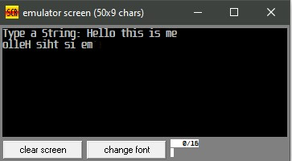

**Discussion:**

In the above program, a text/string was taken as input and was pushed in a stack using a loop. In the loop CMP instructions were used to check the whether a enter was pressed or not. If it a space was pressed then it jumped to TOP block to pop and store the character into an pre-declared array. Then it went back to C block to take the next input word. This process was repeated until an enter button was pressed. After pressing the enter button, it was checked in the CMP and moved to END_WHILE block to show the whole array as output by printing it on the console.